SIMATS ENGINEERING
ASSESSMENT TOOL 3: Technical Presentation

COURSE NAME: | Cloud Computing and Big Data Analytics | COURSE CODE: | CSA1519

COURSE OUTCOME COVERED
CO1: Apply cloud computing technologies including hardware-software evolution, virtualization, web services, and service models to develop cloud-based solutions. (BL2)
Assessment Tool Weightage: 10%

Dave's Taxonomy: Imitation (Level 1)  Question Count: 5 | Total Marks: 25

Code of Conduct
I SARVAJITH S (192565079) certify that this submission is my original work and that I have adhered to the guidelines specified for this assessment.
I understand that any violation of academic integrity rules will result in disciplinary action.

Signature of the student: SARVAJITH S

Assessment Tasks
Technical Presentation Topic
- Cloud Storage Technologies: Object, Block, and File Storage Compared
  - Compare storage architectures, use cases, and industry adoption patterns.

Technical Presentation Rubric

Criteria | Weightage | Level 4 - Exemplary | Level 3 - Proficient | Level 2 - Developing | Level 1 - Beginning
Technical Content | 30% | Content is highly accurate, relevant, and insightful | Content is correct with minor gaps | Basic content with limited depth | Content is inaccurate or superficial
Structure and Flow | 20% | Excellent logical flow and slide organization | Good structure with minor issues | Some organization but weak flow | Disorganized presentation
Use of Visuals | 15% | Visuals strongly support technical communication | Relevant visuals used well | Limited or unclear visuals | No meaningful visuals
Communication Skills | 20% | Confident, clear, and engaging delivery | Clear delivery with minor hesitation | Moderate clarity but uneven delivery | Weak delivery and low clarity
Professionalism | 15% | Well-prepared and audience-focused presentation | Mostly professional | Basic preparation visible | Poor preparation and professionalism

Topic : Cloud Storage Technologies: Object, Block, and File Storage Compared

Introduction :
- Cloud storage enables users and applications to store, manage, and access data through cloud-based infrastructure.
- It provides scalable, flexible, and on-demand storage without depending entirely on local hardware.
- Object, Block, and File Storage are the three major storage models used in cloud computing.
- Each storage model is designed for different data structures, access methods, performance needs, and application workloads.

Objective :

- The aim is to understand the working principles of Object, Block, and File Storage in cloud computing.
- The objective is to compare their architecture, performance, scalability, and accessibility.
- The presentation identifies the most suitable use cases for each type of cloud storage.
- It also studies how these storage technologies are adopted in real-world cloud platforms.

Core technical explanation:

- Object Storage stores data as independent objects along with metadata and a unique identifier.
- Block Storage divides data into fixed-size blocks and provides high-speed access for performance-intensive applications.
- File Storage organizes data in a hierarchical structure of files and folders for simple shared access.
- These storage models differ mainly in architecture, access method, scalability, performance, and suitable use cases.

Architecture or process diagram:

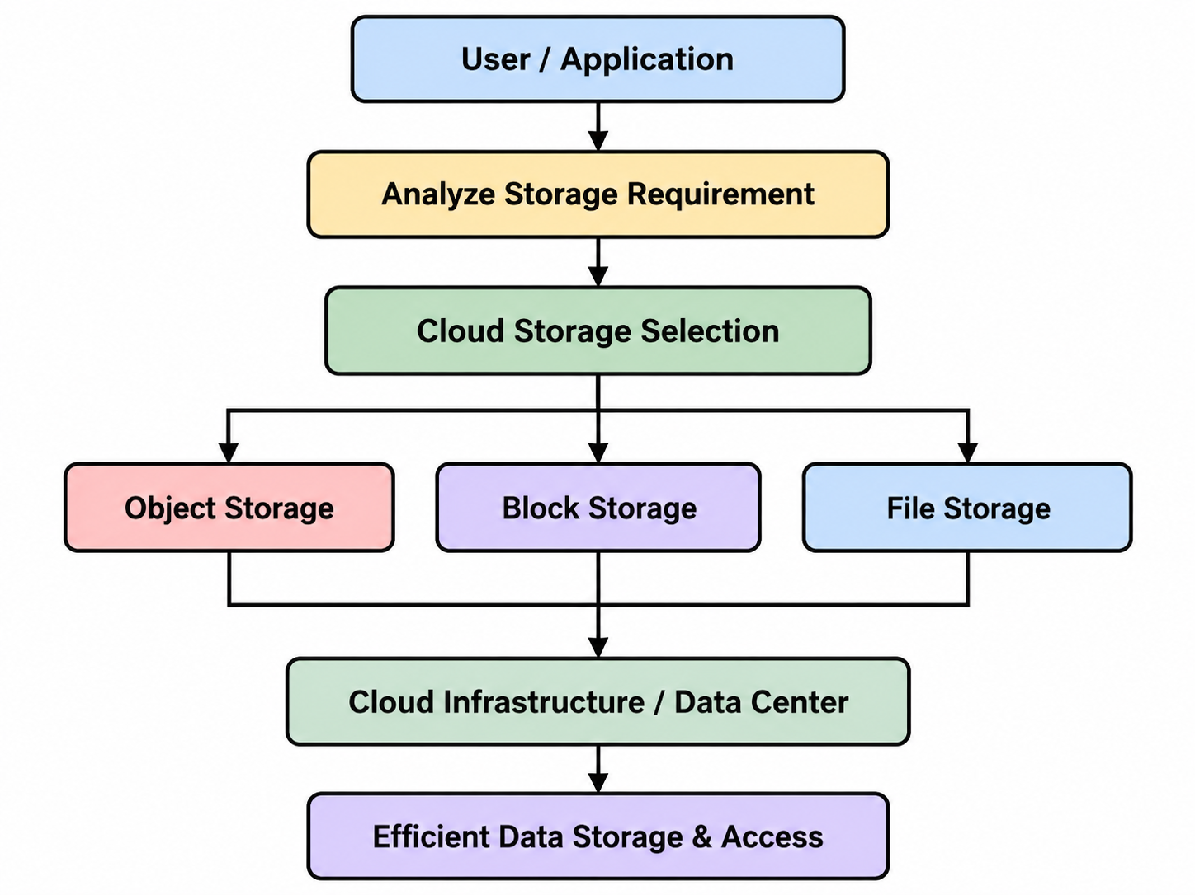

Real-world use case:

- Amazon S3 is widely used as Object Storage for backups, media files, data lakes, and large unstructured datasets.
- Amazon EBS provides Block Storage for virtual machines, databases, and applications that require high-performance access.
- Amazon EFS offers File Storage for shared folders and applications that need access from multiple cloud servers.
- These AWS services show how different storage technologies are selected based on application workload and data requirements.

Conclusion and key takeaway:
- Object, Block, and File Storage serve different purposes in cloud computing environments.
- Object Storage provides high scalability, Block Storage offers strong performance, and File Storage supports simple shared access.
- Selecting the correct storage type improves efficiency, accessibility, and application performance.
- Understanding these technologies helps organizations choose the most suitable cloud storage solution for their workloads.

Photo of the presentation :

